Woodstock Middle School Track Club – Parent Meeting (2025)
Introductions of Coaches:
Coach Jason Farris - Boys Head Coach – 843.696.6440 - WMStandF@gmail.com
Coach Leslie – Gils Head Coach
Coach Horton – Lead Long Distance Coach
Coach Brandon – Lead Coach, sprints, hurdles
Coach Rickoe – Lead Coach Long Jump, Mid-Distance
Parent Volunteers Needed!
To run a club on a day-to-day basis of roughly 100 athletes requires parent volunteers. We need parents to help in many capacities. It does not matter if you are or are not a runner, we have positions for everyone. While the club is growing we are trying to fill volunteer parent positions, for meets, practices, end of year banquet, and more. To become a volunteer, you do not have to have a USATF membership, we will be using sign-up genius for a few volunteer opportunities. We will also have sign-up sheets for parent coaches with more details.
What form of communication is used by the club to reach parents/athletes?
- Email – communication is handled via e-mail from WMStandF@gmail.com
- Website – You will need to go onto the below web-site or scan QR code to register your athlete!!! You can pay dues on the site as well. This platform is where we keep track of all records, times, dues, communication and more.
- Updated information is on the website including calendar with meets and practices.
- http://leagues.bluesombrero.com/woodstockmiddleschooltandf
- Facebook - “Like” us on FB to see updates in your newsfeed – Woodstock Middle Track and Field
- Remind – receive important last-minute texts in case of bad weather/immediate pick up required!
To join Remind… text @abe9b3a to the number 81010 to sign up to receive urgent team text

What are the events in track & field?
We run under IAAF rules with the following running events: 100, 200, 400, 800, 1600, 3200, 4 x100 relay, 4 x 400 relay, 4x200 relay (certain meets) and Hurdles. The field events include the following: long jump, high jump, shot put, discus. Pole vault is not an event in which we participate.
A quick note about running track. There are many team sports that teach teamwork and skills. Running requires endurance, character, pride, physical strength and mental toughness. It is a test, not a game. We have runners of varying abilities. Some have been running with the club for years. Some are completely new to competitive running. We do not expect everyone to win. However, we do ask them to try to give their best. Continual improvement will happen if they put in the work. We can only provide the tools. The athletes need to do the work. Running is about the miles and effort you put in. The end goal is to hope instill a love of running into every athlete. That is something they can take with them throughout their lifetime.
Dues: $285.00
What does the registration fee include?
$285.00 – This covers, Uniforms, book bag, meet fees (per team)*, equipment purchases, food and snacks for meets (we need more), any travel costs for the club, timing fees, administration fees and end of season Banquet.
Dues are refundable only until the first week of official practice. If you your child decides to not participate within this grace period, a full refund will be submitted minus the cost of the custom book bag.
All fees should be paid by 2/27/2025. Uniforms will be distributed prior to the first meet.
What are my meet volunteer obligations?
It is mandatory that at least one parent volunteer per child (or family) to help with the meet we host. The meet is undetermined at this time. We will send out a signup form for various duties at the meet. This includes functions like manning the concession stand, controlling the field access gates, corralling athletes in the bull pen, heat sheet runners, field event scoring, etc. Instructions will be provided prior to the meet. It is truly organized chaos with around 500 athletes competing. If you do not want to volunteer - There is a $65.00 buy-out option as well.
Are there additional expenses required by the athlete?
- The athletes/parents are responsible for transportation to all meets.
- A good pair of running shoes should be purchased for the athlete. It is recommended to have spikes for all sprinters as well. This is important to your athletes advantage.
- We have an option to order team spirit wear with enough interest which is not covered by the team fees.
- We are asking for donations for track meet snacks and drinks for the kids. Anything funds that are left over will be added to the end of season banquet.
- If you would like to donate drink / snack items, please contact coaching staff.
What are the practice times and where
Practices will be 4 days a week for 2 hours. The practice schedule is posted on the website, and our first Pre-practice is Jan 7th from 4:45pm – 6:30pm. The high school has priority usage of the track. If the track is not available, we will be using the bus parking lot for our practices. Our practice location may change, without notice, due to high school scheduling. Pick up and drop off will be at the side parking lot.
The drop off and pick up location is highlighted in the below image:
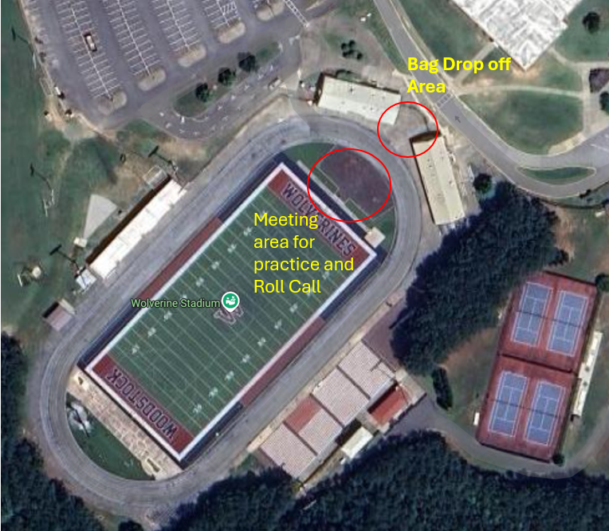
We understand that due to family schedules and schoolwork, you may not make it to every practice. Please do not let school suffer due to practices. However, the more you put into the running, the more you get out of it. Attendance may be taken, but it is simply for recording purposes. Members will be eligible for end of season awards if they participate in one or more meets.
If you know your athlete will not attend practice, we ask that you please inform one of the coach staff or send us a message via email, text, Sports Connect.
What can I expect at practice?
At each practice, the kids will do a warm-up, run, strength and core exercises and a cool down. Practice for field events will be on a rotating basis. They will also get information about running, nutrition, injury care, etc. The information may be verbal and/or written handouts. Practices will be designed and supervised by experienced coaches. Our goal is to train kids physically, motivate them mentally and emotionally, develop interest in running /fitness and most of all we make sure the kids HAVE FUN!
Please do not feed your child a large meal within two hours of a meet or practice. Light snacks and fruit is fine. No dairy within two hours of competing at a meet or coming to practice. We realize that many of the athletes will be getting home from practice shortly before practice. But we would prefer them to be hungry during practice than getting sick. Please DO have them come hydrated. Sending them to school with a water bottle is very helpful with this, so that they are hydrating throughout the day.
If your child has asthma, please make sure they have an inhaler with them. Also, please be sure you noted this on the registration information. If not, please let us know.
If any athlete has an injury, have them bring that to the attention of a coach. We will make recommendations and/or limit/abstain from practicing.
Please make sure that your children arrive at practice in appropriate attire for the outside temperature.
Also, if they have team apparel, please make sure that you have written their name somewhere on it.
What can I expect at meets?
Developmental meets are run at local high schools on Saturdays starting 1st of March and into May. They typically start at _{8am}. If your child participates in another sport, you may be able to work around the events that your child will participate in. The only way you can guarantee your child will make their event is to be at the track.
The season builds up to the most important meet which is the Area/Association Meet. The children HAVE to participate in this meet in order to advance to the state meet. This is highly encouraged for every runner to do. Please try to plan vacations accordingly.
Some suggestions to bring to the meets: cooler of drinks, food, chairs, umbrellas for shade, book, sunscreen. Warm clothes, we start early in the year, dress appropriately.

Conditioning Starts: January 7th through January 23rd – Three days a week: 5pm – 630pm.
First Official Day of Track Practice: January 27th – 5pm – 7pm – Four Days a week M,T,W,T. (Deadline for Dues)
Tentative Meet Schedule:
- Saturday, March 1st – Marietta HS 8am
- Thursday, March 13th – Cartersville HS *** 4pm
- Saturday, March 15th – Host Home Meet – Middle School*** 8am
- Thursday, April 3rd - Cartersville HS – 4pm
- Saturday, April 12th - Holy Innocents – HIES - 11am
- Saturday, April 19th – Marietta HS – 8am
- April 25th - April 26th - State Championship – Parkview Lilburn, GA
  - *** These meets may conflict with each other. We would like to host a Middle School meet at WMS, but we can not secure this date without having enough volunteers to run a successful track meet.
  - We will need 20 – 30 volunteers to make this happen. We will create sign up sheets and email to parents that register on Sports Connect.
  - If we cannot get enough volunteers we will continue with the Thursday Meet. We will be working with teachers and staff to make this possible for our athletes to participate in a meet during the school week. If you cannot attend these meets, there is no repercussion. We are trying to give our athletes more opportunities to race. As there are not a ton of meet options.
End of Year Banquet:
- TBD – May time period
- What running gear does my child need?
Your child will need to have a pair of athletic running shoes for practice and meets. Appropriate running attire should include warm ups/sweats (earlier in the season), running shorts, long and short sleeved shirts.
Dressed in layers is most important. It will be cold, please make sure your child dresses appropriately!
We have some track tops and bottoms (practice uniforms) we will be selling for $5.00 per pair, quantity and sizes are limited.
It is required that all athletes bring water and/or sports drinks to practices and meets. Write their name on all bottles and clothing they may remove. Make sure what they are picked up with the same items they were dropped off with. No disposable water bottles as they tend to leave them behind. We must clean up after ourselves or face being asked to leave the facility. We are guests!

Where can I buy running shoes?
You can buy running shoes at any of the sports stores. However, the following store has a knowledgeable staff, and a wide selection of shoes size 2 and up. Big Peach Running Company, 1625 Ridenour Blvd NW, Kennesaw.

